WORLD SPACE WEEK 2023

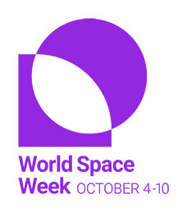

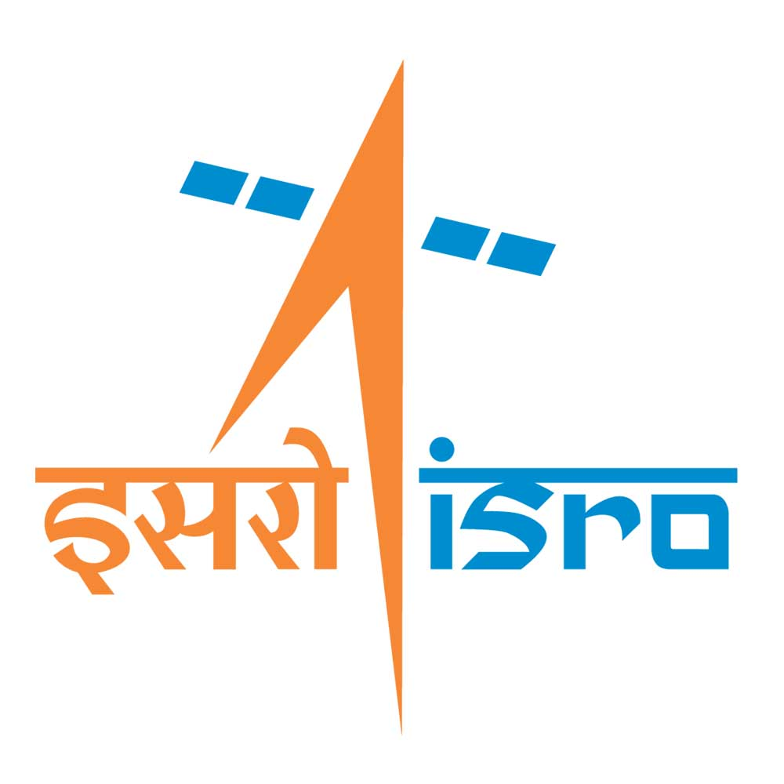

Jointly organized by VSSC,LPSC,IISU

**-------------------------------------------------------------------**

**All Kerala Inter-school Quiz Competition Authorization letter**

I, hereby confirm that the following students are nominated from ______________________________________________________________________________________________________________________________________ (School Name) for All Kerala Inter- School Quiz Competition conducted as part of World Space Week 2023 celebrations.

|  |  |  |
| --- | --- | --- |
| **SN** | **Name of participant** | **Class** |
|  |  |  |
|  |  |  |
|  |  |  |
|  |  |  |
|  |  |  |
|  |  |  |

|  |
| --- |
| Name of the Head of institution / School Co-ordinator:  Signature (With School Seal): |

Note:

1. Maximum of 6 participants can participate from a school.
2. Kindly take print of this form, fill, sign and upload in pdf format at the time of registration.